5. Які задачі системного адміністрування можна реалізувати на базі ОС Linux?

The main tasks of system administration based on Linux are

* Managing users and groups (creating, deleting and managing users and groups, granting access rights to files and directories)
* Network configuration
* Process management (start, suspend, resume, delete processes)
* Security settings (setting access rights to files)
* Software update and management

This diagram shows the work of a system administrator in a good way:

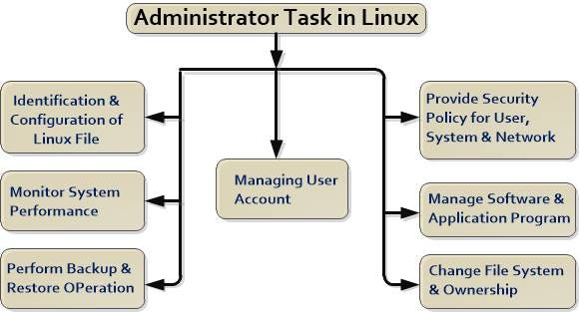

6. Як пов’язані між собою ОС Android та Linux?

The Linux kernel is the most popular operating system, while the Android framework is built on top of the Linux kernel. Linux is the core part of the Android operating system but it does not include more like a linux. The android developers can modify the linux kernel as per their requirements. That is to say all Android devices use the Linux kernel, but Android is not present in every Linux device.

7. Основні можливості та сфера використання Embedded Linux?

Key features of embedded Linux include a small footprint, support for real-time applications, power management capabilities, a variety of networking protocols, and customizable user interfaces. The main application of Embedded Linux is to power specially designed hardware for specialised use cases.

8. Яким чином можна змінити типу завантаження Linux: в текстовому режимі (3 рівень) або графічному (рівень 5)? Чим відрізняються режими CLI та GUI?

The procedure is as follows to change into a text mode runlevel under systemd:

* Open the terminal application.
* For remote Linux servers, use the ssh command.
* Find which target unit is used by default: systemctl get-default
* To change boot target to the text mode: sudo systemctl set-default multi-user.target
* Reboot the system using the reboot command: sudo systemctl reboot

Want to revert change boot to GUI instead of text mode?

* Open the Linux terminal application.
* Again, for remote Linux servers, use the ssh command.
* Find which target unit is used by default: systemctl get-default
* To change boot target to the GUI mode: sudo systemctl set-default graphical.target
* Make sure you reboot the Linux box using the command: sudo reboot

The difference between GUI and CLI:

|  |  |
| --- | --- |
| CLI | GUI |
| CLI is difficult to use. | Whereas it is easy to use. |
| It consumes low memory. | While consuming more memory. |
| In CLI we can obtain high precision. | While in it, low precision is obtained. |
| CLI is faster than GUI. | The speed of GUI is slower than CLI. |
| CLI operating system needs only a keyboard. | While GUI operating system needs both a mouse and keyboard. |
| CLI’s appearance can not be modified or changed. | While its appearance can be modified or changed. |
| In CLI, input is entered only at a command prompt. | While in GUI, the input can be entered anywhere on the screen. |
| In CLI, the information is shown or presented to the user in plain text and files. | While in GUI, the information is shown or presented to the user in any form such as: plain text, videos, images, etc. |
| In CLI, there are no menus provided. | While in GUI, menus are provided. |
| There are no graphics in CLI. | While in GUI, graphics are used. |
| Some command-line environments provide multitasking but it is complicated to see several things on one screen. | GUI enables a user to easily observe and operate various things at once. |
| CLI enables a user to simply script a series of instructions to carry out a task or execute a program. | GUI does not provide the facility to script a sequence of commands. |